**МИНИСТЕРСТВО ЦИФРОВОГО РАЗВИТИЯ, СВЯЗИ И МАССОВЫХ КОММУНИКАЦИЙ РОССИЙСКОЙ ФЕДЕРАЦИИ**

Ордена Трудового Красного Знамени федеральное государственное бюджетное образовательное учреждение высшего образования

**МТУСИ**

**Отчёт по дисциплине**

**Введение в ИТ**

Выполнил: студент гр. БИН2003 Пантелеев С.В.

Проверил: Аршинов Е.А.

Москва 2021

TELEBOT

Программа

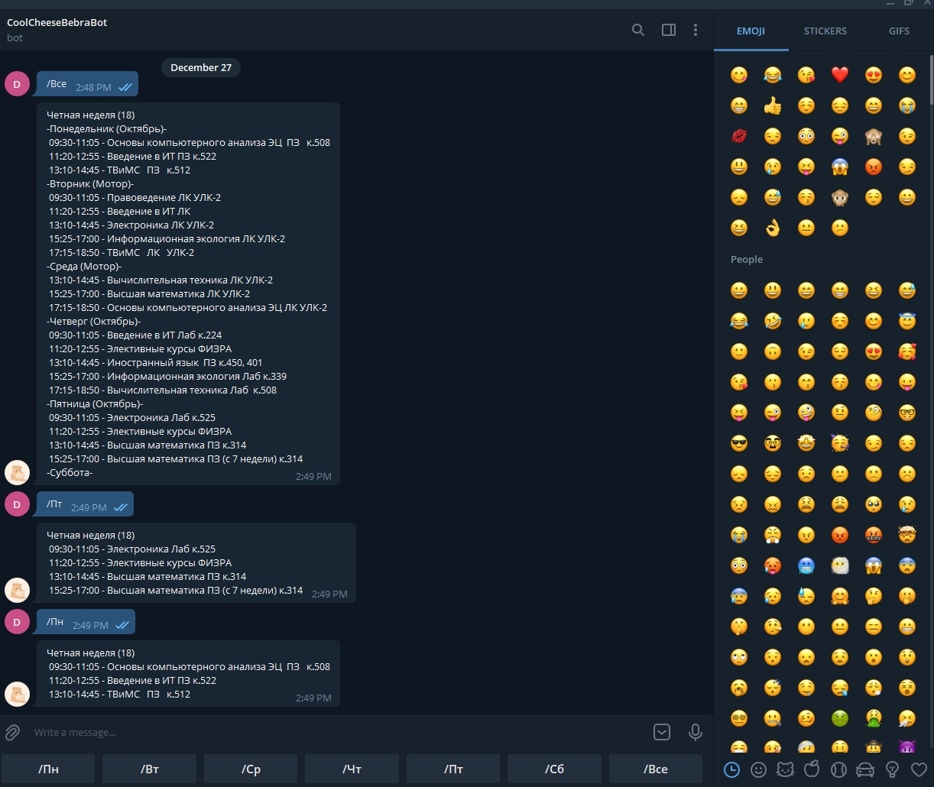

Код main

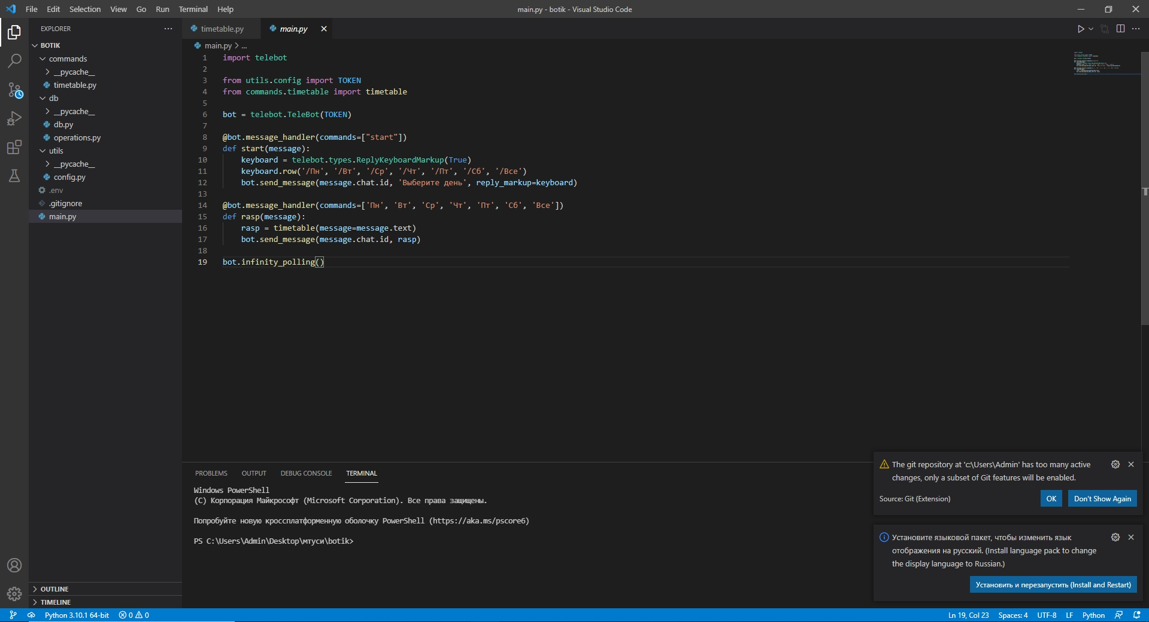

Код timetable

from datetime import date

from db.operations import simple_select

from db.db import conn, cur

week_day = {'пн': range(0, 5),

'вт': range(5, 10),

'ср': range(10, 15),

'чт': range(15, 20),

'пт': range(20, 25),

'сб': range(25, 30)}

spaces = '&#4448;&#4448;&#4448;&#4448;&#4448;'

long_lines = '--'

short_lines = '-'

days = ['Понедельник (Октябрь)',

'Вторник (Мотор)',

'Среда (Мотор)',

'Четверг (Октябрь)',

'Пятница (Октябрь)',

'Суббота',

'Воскресенье']

days_with_spaces = [f'{short_lines}{day}{short_lines}' for day in days]

time = [' 09:30-11:05 -', ' 11:20-12:55 -', ' 13:10-14:45 -', ' 15:25-17:00 -', ' 17:15-18:50 -']

def timetable(message):

message_array = message.split(' ')

delta = delta_func()

nech = simple_select(conn, cur, select_what=['class_name'], select_from='timetable', where="week = 'неч'")

ch = simple_select(conn, cur, select_what=['class_name'], select_from='timetable', where="week = 'чет'")

week_type = {'чет': ch, 'нечет': nech}

if len(message_array) == 1 and message_array[0] == '/Все':

rasp = ch if (delta // 7) % 2 != 0 else nech

day = []

for r in range(0, 30):

day.append(rasp[r])

text = rasp_with_time(day, 6)

return text

elif len(message_array) == 1 and message_array[0] != '/Все':

arg = message_array[0][1:].lower()

day = []

rasp = ch if (delta // 7) % 2 != 0 else nech

for r in week_day[arg]:

day.append(rasp[r])

text = rasp_with_time(day, 1)

return text

elif len(message_array) == 2:

arg = message_array[1]

if arg in week_day:

day = []

rasp = ch if (delta // 7) % 2 != 0 else nech

for r in week_day[arg]:

day.append(rasp[r])

text = rasp_with_time(day, 1)

return text

elif arg in week_type:

rasp = week_type[arg]

day = []

for r in range(0, 30):

day.append(rasp[r])

text = rasp_with_time(day, 6, nofw=False)

return text

elif len(message_array) == 3:

day_of_the_week = message_array[1]

type_of_the_week = message_array[2]

rasp = week_type[type_of_the_week]

day = []

for r in week_day[day_of_the_week]:

day.append(rasp[r])

text = f'{day_of_the_week.capitalize()} | {type_of_the_week.capitalize()}ная неделя\n{rasp_with_time(day, 1, nofw=False)}'

return text

def rasp_with_time(pr, mn, nofw=True):

if nofw:

delta = delta_func()

week_number = (delta // 7) + 1

week = f'Четная неделя ({week_number})' if (delta // 7) % 2 != 0 else f'Нечетная неделя ({week_number})'

text = f'{week}\n'

else:

text = ''

for i, item in enumerate(time * mn):

if i % 5 == 0 and mn > 1:

text = text + days_with_spaces[i//5] + '\n'

if pr[i] != None:

text = text + str(item) + ' ' + pr[i] + '\n'

return text

def delta_func():

first_day = date(2021, 8, 30)

today = date.today()

delta = (today - first_day).days

return delta